BANK LOAN REPORT QUERY
Total Loans Applications
SELECT COUNT(id) AS total_loan_applications
FROM bank_loan
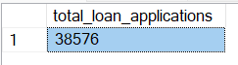

-- MTD loan applications

SELECT
COUNT(id) AS mtd_total_loan_applications
FROM bank_loan
WHERE
MONTH(issue_date) = 12 AND
YEAR(issue_date) =
(SELECT
MAX(YEAR(issue_date))
FROM bank_loan)
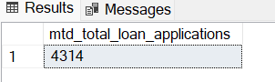

-- PMTD loan applications

SELECT
COUNT(id) AS mtd_total_loan_applications
FROM bank_loan
WHERE
MONTH(issue_date) = 11 AND
YEAR(issue_date) =
(SELECT
MAX(YEAR(issue_date))
FROM bank_loan)

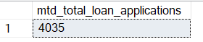

-- (MTD - PMTD) / PMTD the formula to returns the % increase or decrease MoM

WITH mtd_loan AS (
SELECT
COUNT(id) AS mtd_total_loan_applications
FROM
bank_loan
WHERE
MONTH(issue_date) = 12 AND
YEAR(issue_date) = (
SELECT
MAX(YEAR(issue_date))
FROM
bank_loan)),

pmtd_loan AS (
SELECT
COUNT(id) AS pmtd_total_loan_applications
FROM
bank_loan
WHERE
MONTH(issue_date) = 11 AND
YEAR(issue_date) = (
SELECT
MAX(YEAR(issue_date))
FROM bank_loan))

SELECT
(mtd_total_loan_applications * 1.0 - pmtd_total_loan_applications) /
pmtd_total_loan_applications AS MoM_loan_applications
FROM
mtd_loan, pmtd_loan
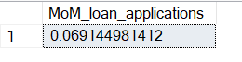
-- Total Funded Amount

SELECT
SUM(loan_amount) AS total_amount_funded
FROM
bank_loan
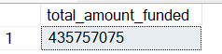
--MTD Total funded Amount

SELECT
SUM(loan_amount) AS mtd_total_amount_funded
FROM
bank_loan
WHERE
MONTH(issue_date) = 12 AND
YEAR(issue_date) = (
SELECT
MAX(YEAR(issue_date))
FROM
bank_loan)
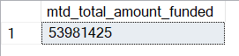
-- PMTD Total funded Amount

SELECT
SUM(loan_amount) AS pmtd_total_funded_amount
FROM bank_loan
WHERE
MONTH(issue_date) = 11 AND
YEAR(issue_date) =
(SELECT
MAX(YEAR(issue_date))
FROM bank_loan)
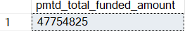

--Total Funded Amount Month-over-Month %

WITH mtd_funded AS (
SELECT
SUM(loan_amount) AS mtd_total_funded_amount
FROM
bank_loan
WHERE
MONTH(issue_date) = 12 AND
YEAR(issue_date) = (
SELECT
MAX(YEAR(issue_date))
FROM
bank_loan)),

pmtd_funded AS (
SELECT
SUM(loan_amount) AS pmtd_total_funded_amount
FROM
bank_loan
WHERE
MONTH(issue_date) = 11 AND
YEAR(issue_date) = (
SELECT
MAX(YEAR(issue_date))
FROM bank_loan))

SELECT
(mtd_total_funded_amount * 1.0 - pmtd_total_funded_amount) /
pmtd_total_funded_amount AS MoM_total_funde_amount
FROM
mtd_funded, pmtd_funded

-- Total Amount Received

SELECT
SUM(total_payment) AS total_amount_funded
FROM
bank_loan
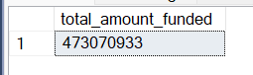
-- MTD Total Amount Received

SELECT
SUM(total_payment) AS mtd_total_amount_received
FROM
bank_loan
WHERE
MONTH(issue_date) = 12 AND
YEAR(issue_date) = (
SELECT
MAX(YEAR(issue_date))
FROM
bank_loan
)
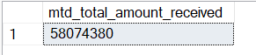
-- PMTD Total Amount Received

SELECT
SUM(total_payment) AS pmtd_total_amount_received
FROM
bank_loan
WHERE
MONTH(issue_date) = (
SELECT
MAX(MONTH(issue_date)) -1
FROM
bank_loan) AND
YEAR(issue_date) = (
SELECT
MAX(YEAR(issue_date))
FROM
bank_loan
)
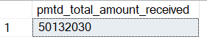
-- MoM Total Amount Received %

WITH mtd_received AS (
SELECT
SUM(total_payment) AS mtd_total_received
FROM
bank_loan
WHERE
MONTH(issue_date) = 12 AND
YEAR(issue_date) = (
SELECT
MAX(YEAR(issue_date))
FROM
bank_loan)),

pmtd_received AS (
SELECT
SUM(total_payment) AS pmtd_total_received
FROM
bank_loan
WHERE
MONTH(issue_date) = 11 AND
YEAR(issue_date) = (
SELECT
MAX(YEAR(issue_date))
FROM bank_loan))

SELECT
(mtd_total_received * 1.0 - pmtd_total_received) /
pmtd_total_received AS MoM_total_received
FROM
mtd_received, pmtd_received
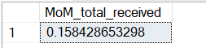
--Average Interest Rate
SELECT
ROUND(AVG(int_rate) * 100.00,2) AS avg_interest_rate
FROM
bank_loan
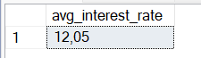
--MTD Average Interest Rate

SELECT
ROUND(AVG(int_rate) * 100,2) AS mtd_avg_int_rate
FROM
bank_loan
WHERE
MONTH(issue_date) = 12 AND
YEAR(issue_date) = (
SELECT
MAX(YEAR(issue_date))
FROM
bank_loan
)
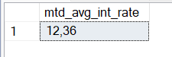
--PMTD Average Interest Rate

SELECT
ROUND(AVG(int_rate) * 100,2) AS pmtd_avg_int_rate
FROM
bank_loan
WHERE
MONTH(issue_date) = 11 AND
YEAR(issue_date) = (
SELECT
MAX(YEAR(issue_date))
FROM
bank_loan
)

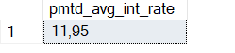
-- Average Interest Rate MoM
WITH mtd_interest AS (
SELECT
ROUND(AVG(int_rate) * 100,2) AS mtd_int_rate
FROM
bank_loan
WHERE
MONTH(issue_date) = 12 AND
YEAR(issue_date) = (
SELECT
MAX(YEAR(issue_date))
FROM
bank_loan)),

pmtd_interest AS (
SELECT
ROUND(AVG(int_rate) *100,2) AS pmtd_int_rate
FROM
bank_loan
WHERE
MONTH(issue_date) = 11 AND
YEAR(issue_date) = (
SELECT
MAX(YEAR(issue_date))
FROM bank_loan))

SELECT
(mtd_int_rate * 1.0 - pmtd_int_rate) /
pmtd_int_rate AS MoM_int_rate
FROM
mtd_interest, pmtd_interest
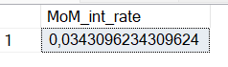
-- Average DTI
SELECT
ROUND(AVG(dti) * 100.00,2) AS avg_dti
FROM
bank_loan


-- MTD Average DTI
SELECT
ROUND(AVG(dti) * 100,2) AS mtd_avg_dti
FROM
bank_loan
WHERE
MONTH(issue_date) = 12 AND
YEAR(issue_date) = (
SELECT
MAX(YEAR(issue_date))
FROM
bank_loan
)
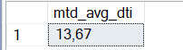
-- PMTD Average DTI
SELECT
ROUND(AVG(dti) * 100,2) AS pmtd_avg_dti
FROM
bank_loan
WHERE
MONTH(issue_date) = 11 AND
YEAR(issue_date) = (
SELECT
MAX(YEAR(issue_date))
FROM
bank_loan
)

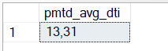

WITH mtd_dti AS (
SELECT
ROUND(AVG(dti) * 100,2) AS mtd_dti
FROM
bank_loan
WHERE
MONTH(issue_date) = 12 AND
YEAR(issue_date) = (
SELECT
MAX(YEAR(issue_date))
FROM
bank_loan)),

pmtd_dti AS (
SELECT
ROUND(AVG(dti) *100,2) AS pmtd_dti
FROM
bank_loan
WHERE
MONTH(issue_date) = 11 AND
YEAR(issue_date) = (
SELECT
MAX(YEAR(issue_date))
FROM bank_loan))

SELECT
(mtd_dti * 1.0 - pmtd_dti) /
pmtd_dti AS MoM_dti
FROM
mtd_dti, pmtd_dti

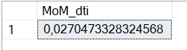

GOOD LOAN ISSUED
--Good Loan Percentage

SELECT
COUNT(
CASE WHEN loan_status IN('Fully Paid', 'Current')
THEN id END)*100.0 / COUNT(*) AS percent_good_loan
FROM
bank_loan
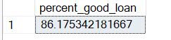

--Good Loan Applications

SELECT
COUNT(
CASE WHEN loan_status IN('Fully Paid', 'Current')
THEN id END) AS good_loan_applications
FROM
bank_loan
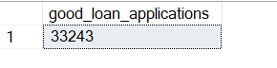
--Good Loan Funded Amount

SELECT
SUM(
CASE WHEN loan_status IN('Fully Paid', 'Current')
THEN loan_amount END) AS good_loan_funded_amount
FROM
bank_loan
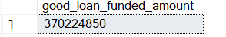
--Good Loan Received Amount
SELECT
SUM(
CASE WHEN loan_status IN('Fully Paid', 'Current')
THEN total_payment END) AS good_loan_received_amount
FROM
bank_loan
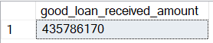

BAD LOAN ISSUED
--Bad Loan Percentage

SELECT
COUNT(
CASE WHEN loan_status = 'Charged Off'
THEN id END)*100.0 / COUNT(*) AS percent_bad_loan
FROM
bank_loan
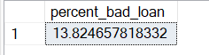
--Bad Loan Applications

SELECT
COUNT(
CASE WHEN loan_status = 'Charged Off'
THEN id END) AS bad_loan_applications
FROM
bank_loan

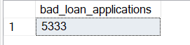
--Bad Loan Funded Amount

SELECT
SUM(
CASE WHEN loan_status = 'Charged Off'
THEN loan_amount END) AS bad_loan_funded_amount
FROM
bank_loan
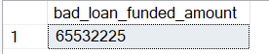
--Bad Loan Received Amount

SELECT
SUM(
CASE WHEN loan_status = 'Charged Off'
THEN total_payment END) AS bad_loan_received_amount
FROM
bank_loan
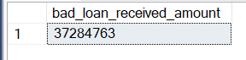

LOAN STATUS
--Loan Status

WITH mtd AS (SELECT
loan_status,
SUM(loan_amount) AS total_amount_funded,
SUM(total_payment) AS total_amount_received
FROM
bank_loan
WHERE
MONTH(issue_date) = 12 AND
YEAR(issue_date) = (
SELECT
MAX(YEAR(issue_date))
FROM
bank_loan)
GROUP BY loan_status)

SELECT
bl.loan_status,
COUNT(id) AS total_loan_applications,
SUM(loan_amount) AS total_funded_amount,
SUM(total_payment) AS total_received_amount,
AVG(int_rate)*100.0 AS avg_int_rate,
AVG(dti)*100.0 AS avg_dti,
mtd.total_amount_funded,
mtd.total_amount_received
FROM
bank_loan AS bl
INNER JOIN mtd
ON bl.loan_status = mtd.loan_status
GROUP BY
bl.loan_status,
mtd.total_amount_funded,
mtd.total_amount_received

-- Monthly trends by Issue Date

SELECT
MONTH(issue_date) AS num_month,
DATENAME(MONTH,issue_date) AS month_name,
COUNT(id) AS total_loan_applications,
SUM(loan_amount) AS total_funded_amount,
SUM(total_payment) AS total_received_amount
FROM
bank_loan
GROUP BY
DATENAME(MONTH,issue_date),
MONTH(issue_date)
ORDER BY
MONTH(issue_date)
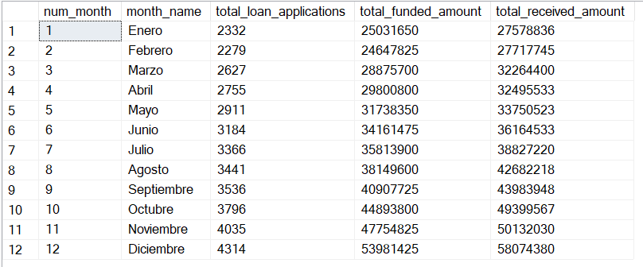

--Regional Analysis

SELECT
address_state,
COUNT(id) AS total_loan_applications,
SUM(loan_amount) AS total_funded_amount,
SUM(total_payment) AS total_received_amount
FROM
bank_loan
GROUP BY
address_state
ORDER BY
address_state

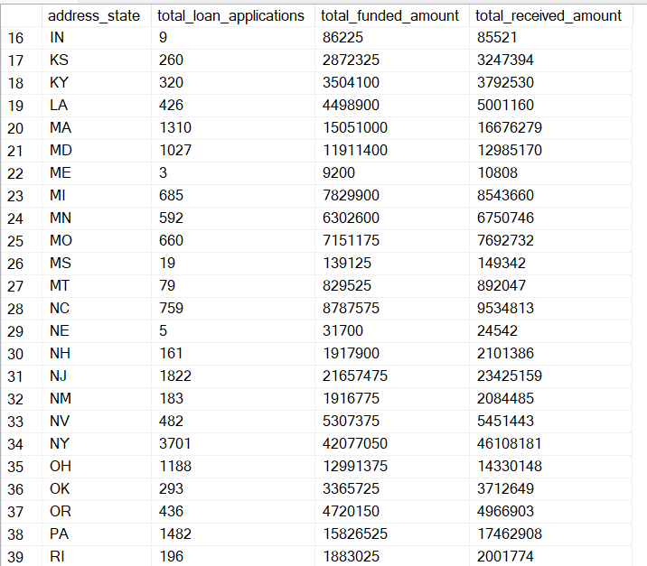

--Loan Term Analysis

SELECT
term,
COUNT(id) AS total_loan_applications,
SUM(loan_amount) AS total_funded_amount,
SUM(total_payment) AS total_received_amount
FROM
bank_loan
GROUP BY
term
ORDER BY
Term

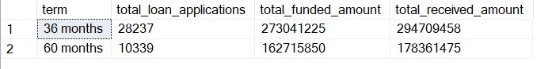

--Employee Length Analysis

SELECT
emp_length,
COUNT(id) AS total_loan_applications,
SUM(loan_amount) AS total_funded_amount,
SUM(total_payment) AS total_received_amount
FROM
bank_loan
GROUP BY
emp_length
ORDER BY
emp_length
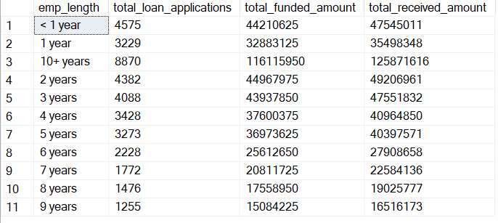

--Loan Porpuse Breakdown

SELECT
purpose,
COUNT(id) AS total_loan_applications,
SUM(loan_amount) AS total_funded_amount,
SUM(total_payment) AS total_received_amount
FROM
bank_loan
GROUP BY
purpose
ORDER BY
Purpose

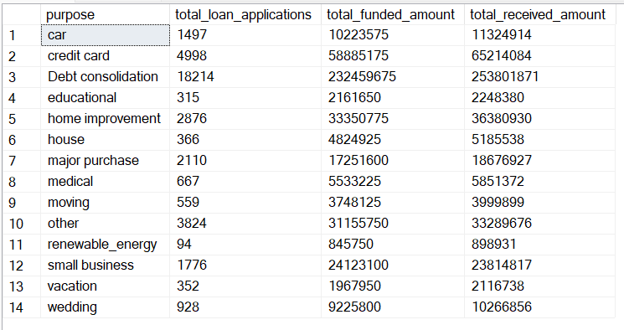
--Home Ownership Analysis

SELECT
home_ownership,
COUNT(id) AS total_loan_applications,
SUM(loan_amount) AS total_funded_amount,
SUM(total_payment) AS total_received_amount
FROM
bank_loan
GROUP BY
home_ownership
ORDER BY
home_ownership

